Credit Card Processing In Ascender
Set Up Credit Cards access in Security Administration

- Credit Cards may need to be added in Security. You will need to create a New Role or edit an existing role to grant Credit Card Information.
Beware of adding conflicting permissions.
Security Administration > Manage Roles or Retrieve the desired role and Edit.

Manage Permissions:
Consider the following permissions and which roles might need the access.
- District Administration > Maintenance > User Profiles
Chose: Purchasing Credit cards
- Finance > Maintenance > Credit Card
Chose: Posting – PA; Posting – PO; Reconciliation
- Finance > Maintenance > Postings
Chose: Purchase Order
- Tables > Credit Card Codes
Chose: Credit Card Codes; Due to Fund
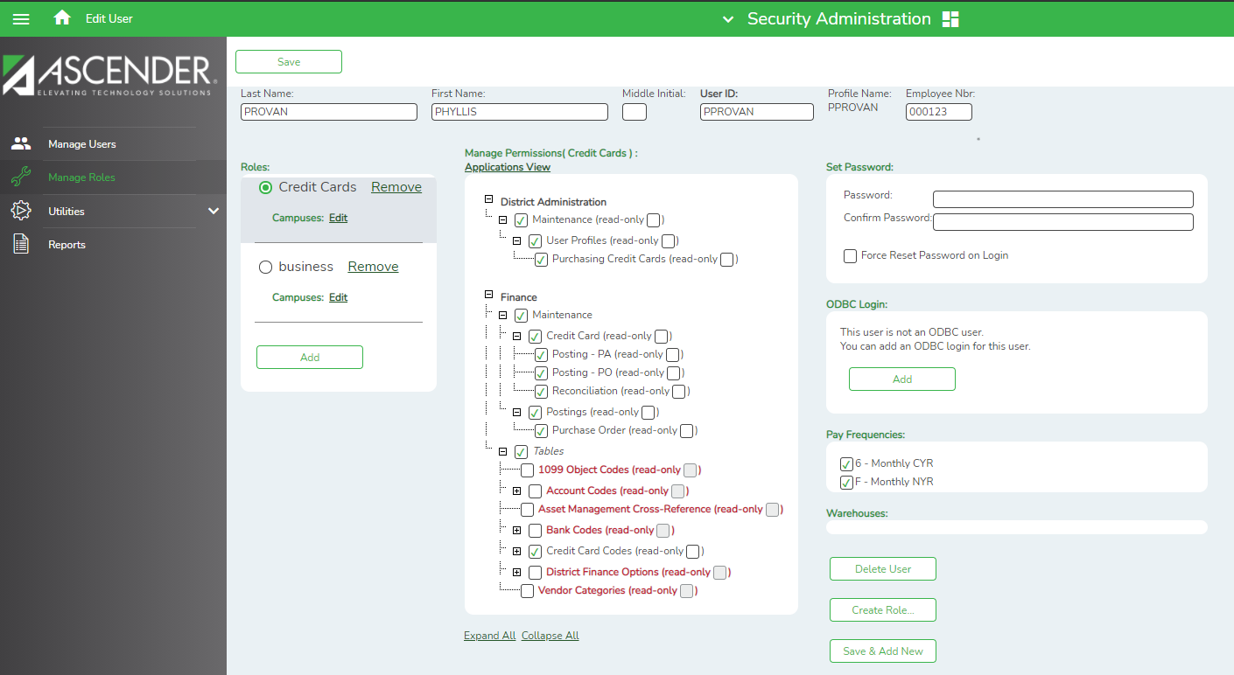

Set Up Credit Cards

- Add a credit card code under:
Finance > Tables > Credit Card Codes

Credit Card Code:
- Type a unique user-defined credit card code. (This district is using the last 4 digits on the credit card)

Description:
- Type a user-defined credit card description.

Vendor Nbr:
- Multiple cards can be set up for each Credit Card vendor.
- Type an active vendor number, if known. The vendor number must exist on the Maintenance > Vendor Information page.
Account Codes:
- The account code must be a liability account (2XXX).
- This account should be different than previously used liability accounts.
  - +Add to add new credit card
A different code is recommended for each card to make it easier to verify transactions.

Sample of Liability Object Codes

Example 1:
Description by Individual User (This will be used if the employee always carries and uses this same card.)
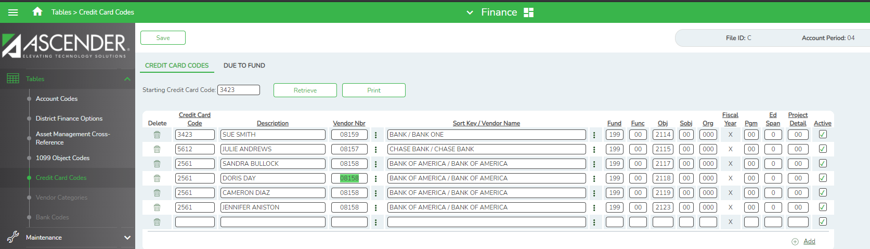

Example 2:
Description by Organization
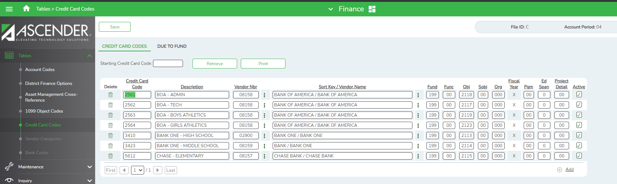

3. Assigning Credit Cards to Users.
District Administration > Maintenance > User Profiles > Purchasing Credit Card tab.

- Assign credit cards to users. Cards assigned to a user will be shown in a dropdown menu when they input requisitions.
- Use the +Add button to add one or more credit cards to the user’s profile.
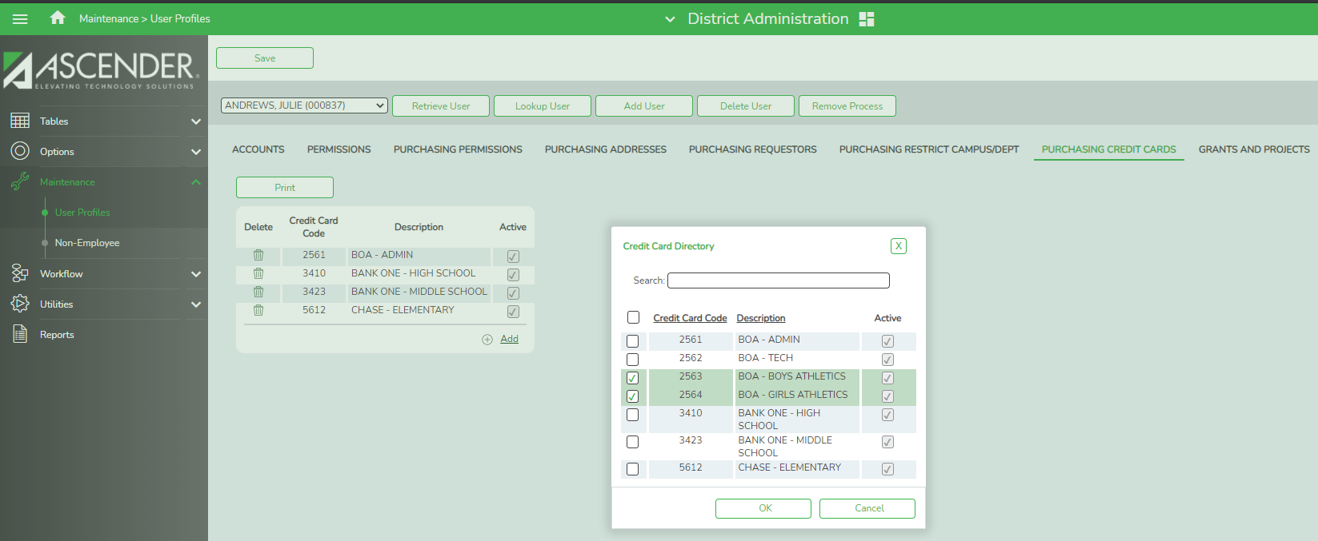

Creating Credit Card Transactions
- Requisition in Purchasing:
  - When creating a requisition, the originator can select a credit card code from the list of credit cards tied to his or her profile. To see a list of available cards, click on the space bar in the Credit Card Code field.
  - We recommend entering credit card information in Bid Nbr field so it prints on the PO. This will assist the Business Office when paying the invoice.

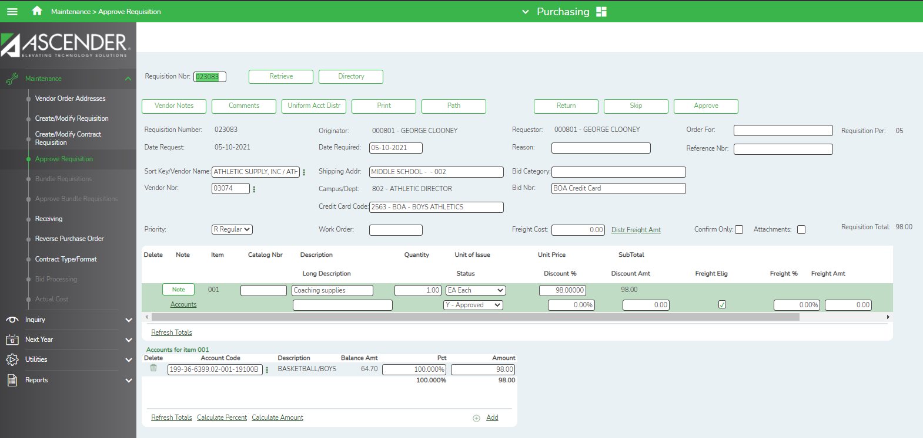

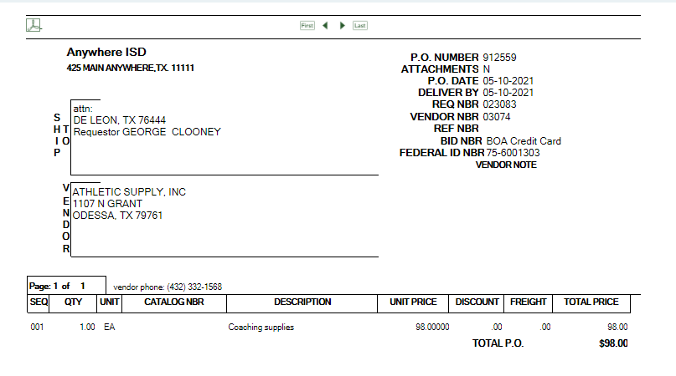

- Once the requisition is approved, the PO can be retrieved on the
Finance > Maintenance > Credit Card > Posting-PO screen
to post the credit card transaction.
When creating a credit card transaction for a purchase order, the general ledger’s expenditure, 4310 reserves for encumbrance and the contra accounts are automatically updated. Also, the outstanding purchase order and vendor files are updated.
Note: The contra account is the credit card account from the credit card table even though it is different from the purchasing fund. This means that due to/due from accounts will be created to complete the accounting transactions.
- Verify that you are in the correct Account Period
- Enter the PO Number – click retrieve

Example 1
Credit Card entered as a Bank Of America – Boys Athletics
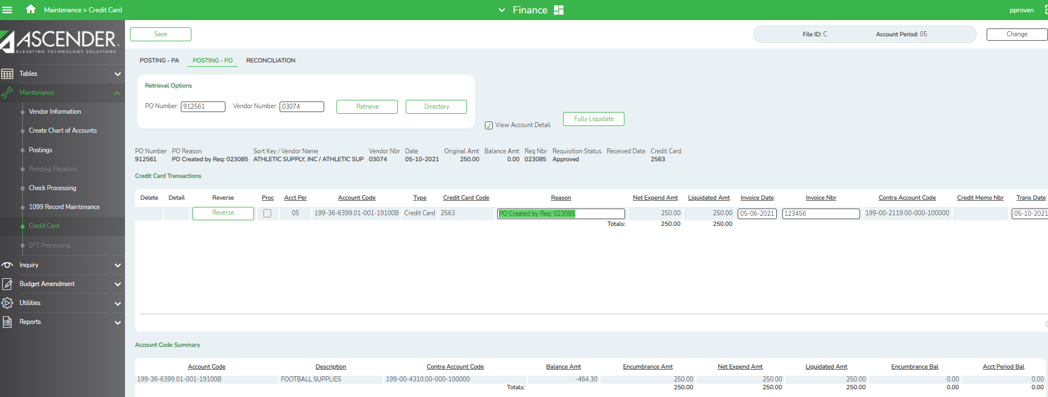
Example 2
Credit Card entered as a Bank One – Middle School
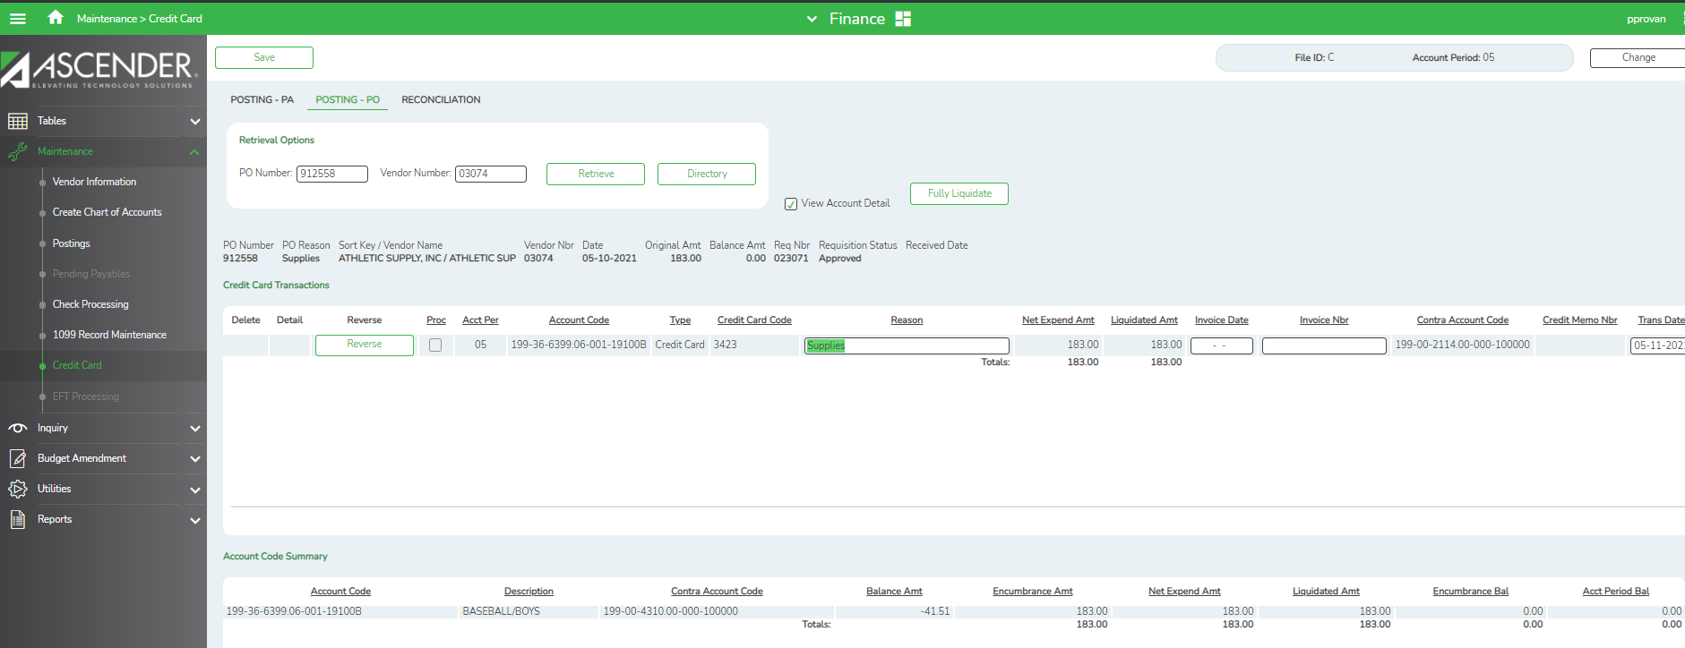
- Purchase Order in Finance
If not using the Purchasing Application, a PO can be created from the
Finance < Maintenance > Postings > Purchase Order tab.
- Select - Add PO
- Enter PO Reason
- Sort Key / Vendor Name
- +Add
- Enter your PO. – Account Code & Encumbrance Amt
- Select – Update Details
- Save the PO & Vendor Nbr to pull in the next step - Credit Cards > Posting –PO
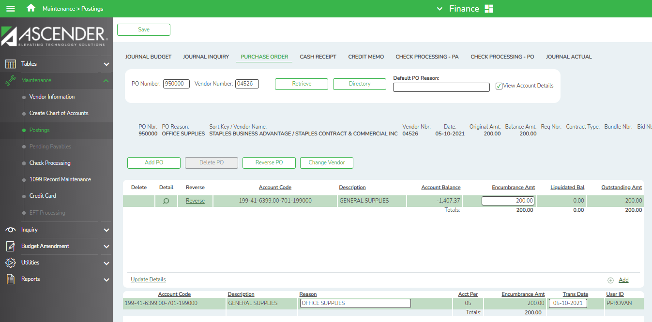

- Retrieve the PO on the
Finance > Maintenance > Credit Card > Posting – PO screen
to post the credit card transaction. Since this transaction was created without a credit card, the following message is displayed.
- The credit card transaction is entered similarly to the Check Processing – PO screen.
- The User can select the type of credit card transaction (purchase or return) and the credit card code for the card used.
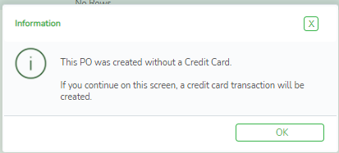
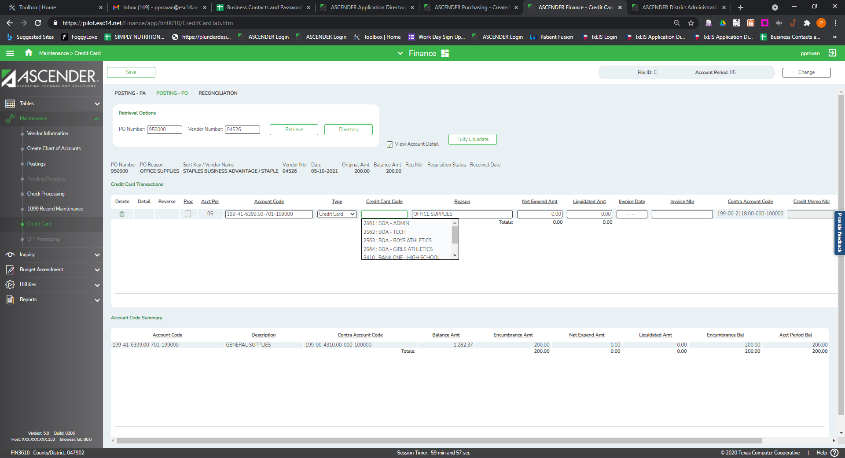

- Credit Card PA in Finance

If a PO was not created, a credit card transaction can be posted as a PA from the
Maintenance > Credit Card > Posting – PA screen.

- Enter Vendor
- +Add
- Enter Account Code
- Select Credit Card Code from the dropdown menu

- Scroll to the right to complete the entry
- Enter Reason
- Enter Net Expend Amt.
- Enter Invoice Date & Invoice Number – if available
- Select Refresh Summary - The Account Code Summary will be completed by Ascender
- The Contra Account Code will be completed for you.

Posting Returns
Since credit card statements will also include returns, returns will need to be posted before reconciling the credit card statement. A return can be entered on either of the Credit Card Posting screens (PO or PA).

- Enter the PA or PO number you need to credit and click Retrieve. You can also click Directory to choose from the list.
- Select the +Add
- Enter the Account Code
- Select Return in the drop down Type field
- Select the Credit Card Code from the drop down
- Enter the Reason for the refund
- On the Net Expend Amt enter a negative amount that is being refunded.

A Credit Memo number will be required prior to saving. The Credit Memo Number is District assigned. You may have to enter it under Postings > Credit Memo to get the number.

Select Refresh Summary before Saving.

Example 1

In this example, a return has been created for $250 to cancel only Mrs. Bullocks TASBO conference registration. This will credit $250.00 out of the $500 Registration
Finance > Maintenance > Credit Card > Posting – PA
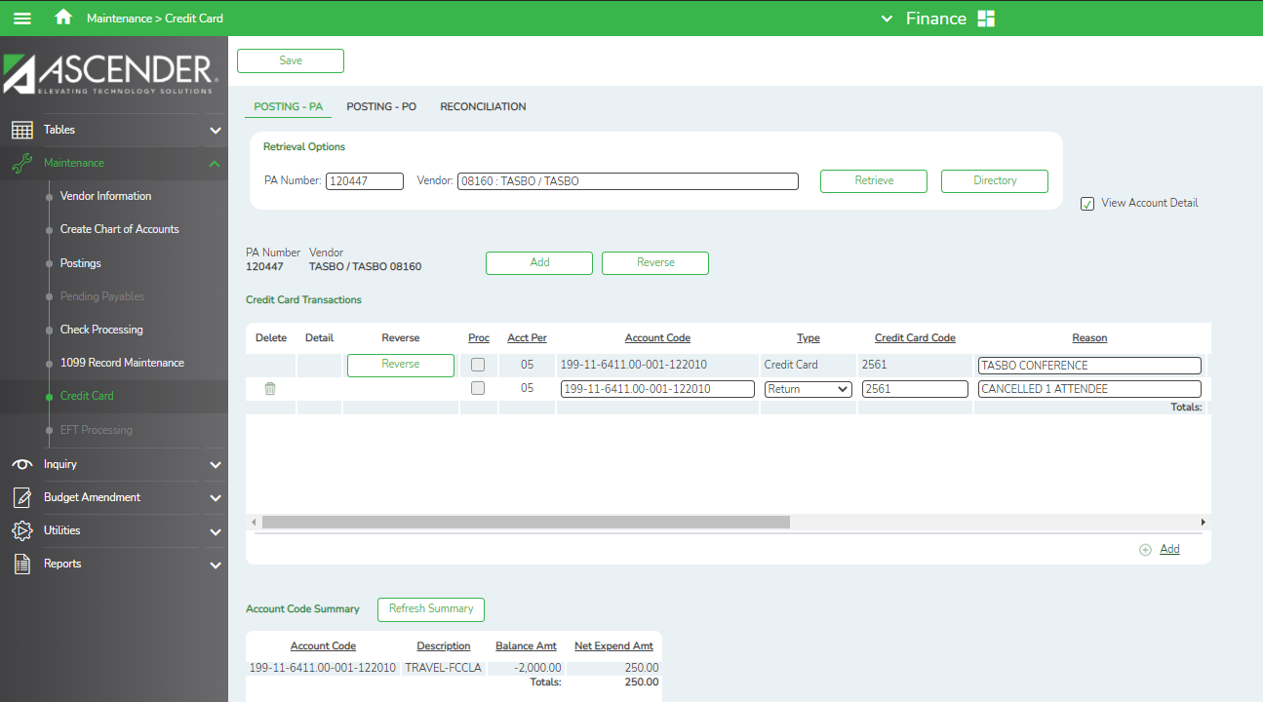
- Scroll to the right to complete the entry.

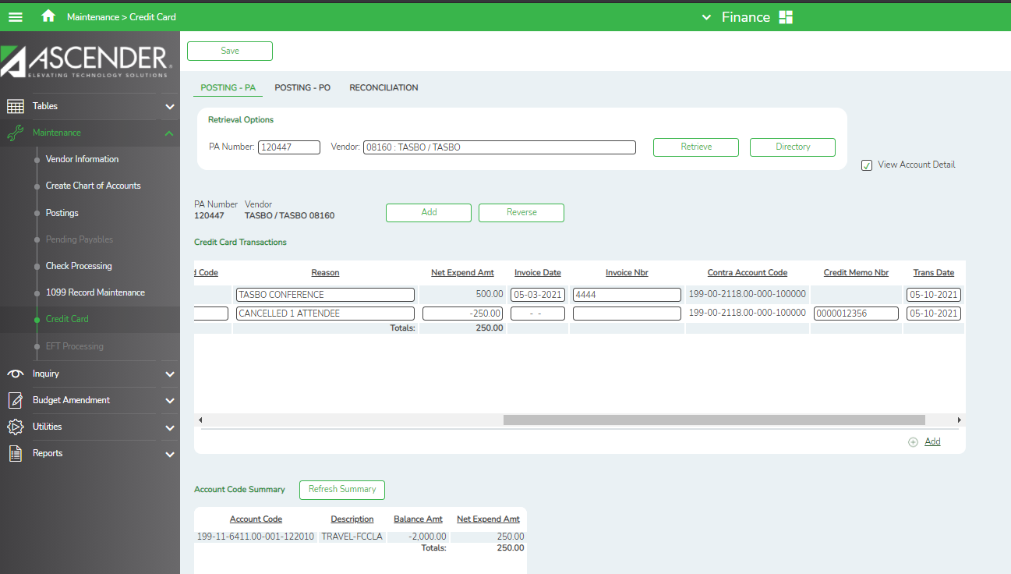

Example 2

In this example, a return has been created for $10 on the Credit Card > Posting – PO screen to reverse charges for football equipment. This PO was created with Credit Card information in the previous month - April.

Enter the PO Number and click Retrieve or choose from the Directory.
  - Select Return in the drop down Type field
  - Select the Credit Card Code from the drop down by using the space bar.
  - Enter the Reason for the refund.
  - On the Net Expend Amt enter the negative amount that is being refunded.
  - Enter the Credit Memo Nbr. A Credit Memo number will be required prior to saving. The Credit Memo Number is District assigned. You may have to enter it under Postings > Credit Memo to get the number.
  - Save.

Finance > Maintenance > Credit Card > Posting – PO

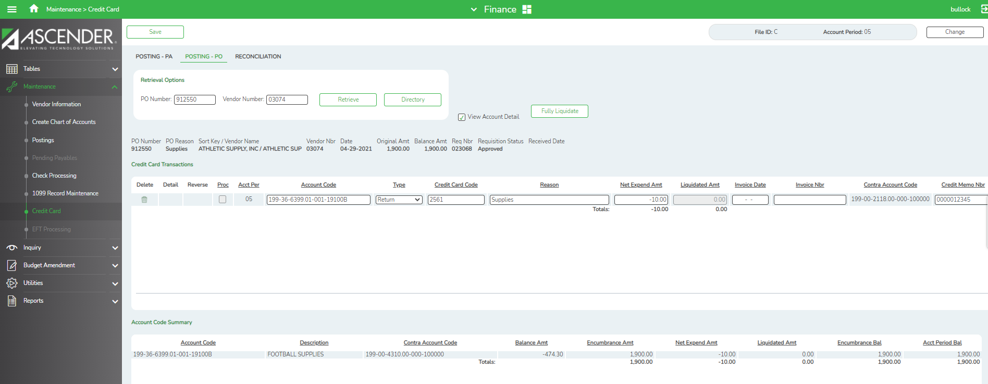

Posting Interests and Misc. Charges
Interest and other miscellaneous charges can be entered as a Credit Card PA transaction. In this example, credit card interest was posted for $25.
- Select Add.
- Enter Vendor – Must be created in the Vendor application
- +Add
- Enter Account Code
- Credit Card Code
- Reason
- Net Expend Amt.

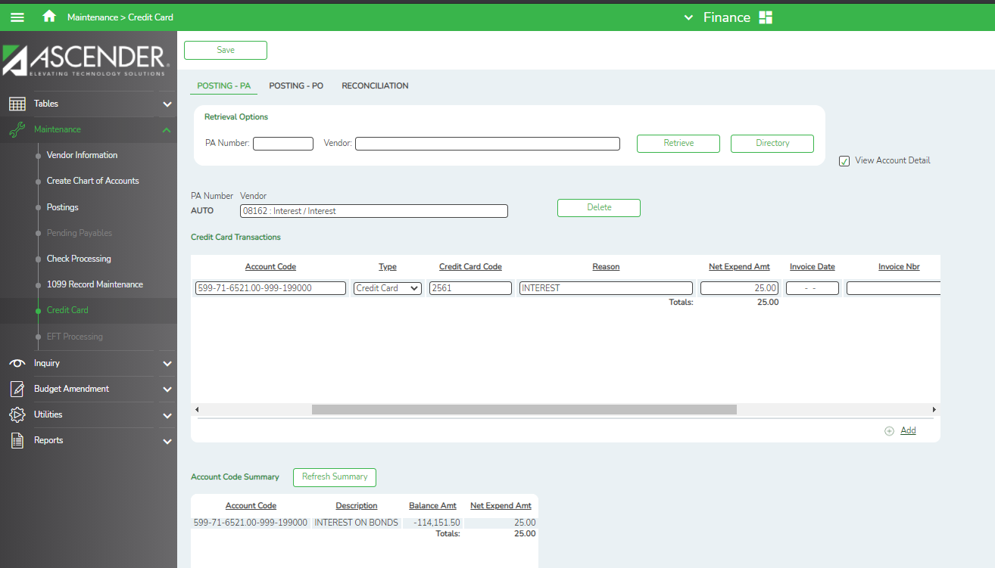

Reconciling Credit Card Statements
After entering all credit card transactions, the credit card statement can be reconciled to the credit card transactions in Ascender,
Finance > Maintenance > Credit Card > Reconciliation
Enter the credit card vendor and credit card code to retrieve all transactions that have been entered for the credit card.
- Enter the Previous Balance and Statement Balance from the Credit Card statement.
- Scroll to the right to see more information under the ‘Credit Card Returns/Payments’ and the ‘Credit Card Charges’.
- Reconcile the transactions.
- Note that as charges or returns are checked off, the Unreconciled Difference will change.
- Click Save as Pending to save and then Reconcile when finished.

Example 1
Bank of America Reconciliation

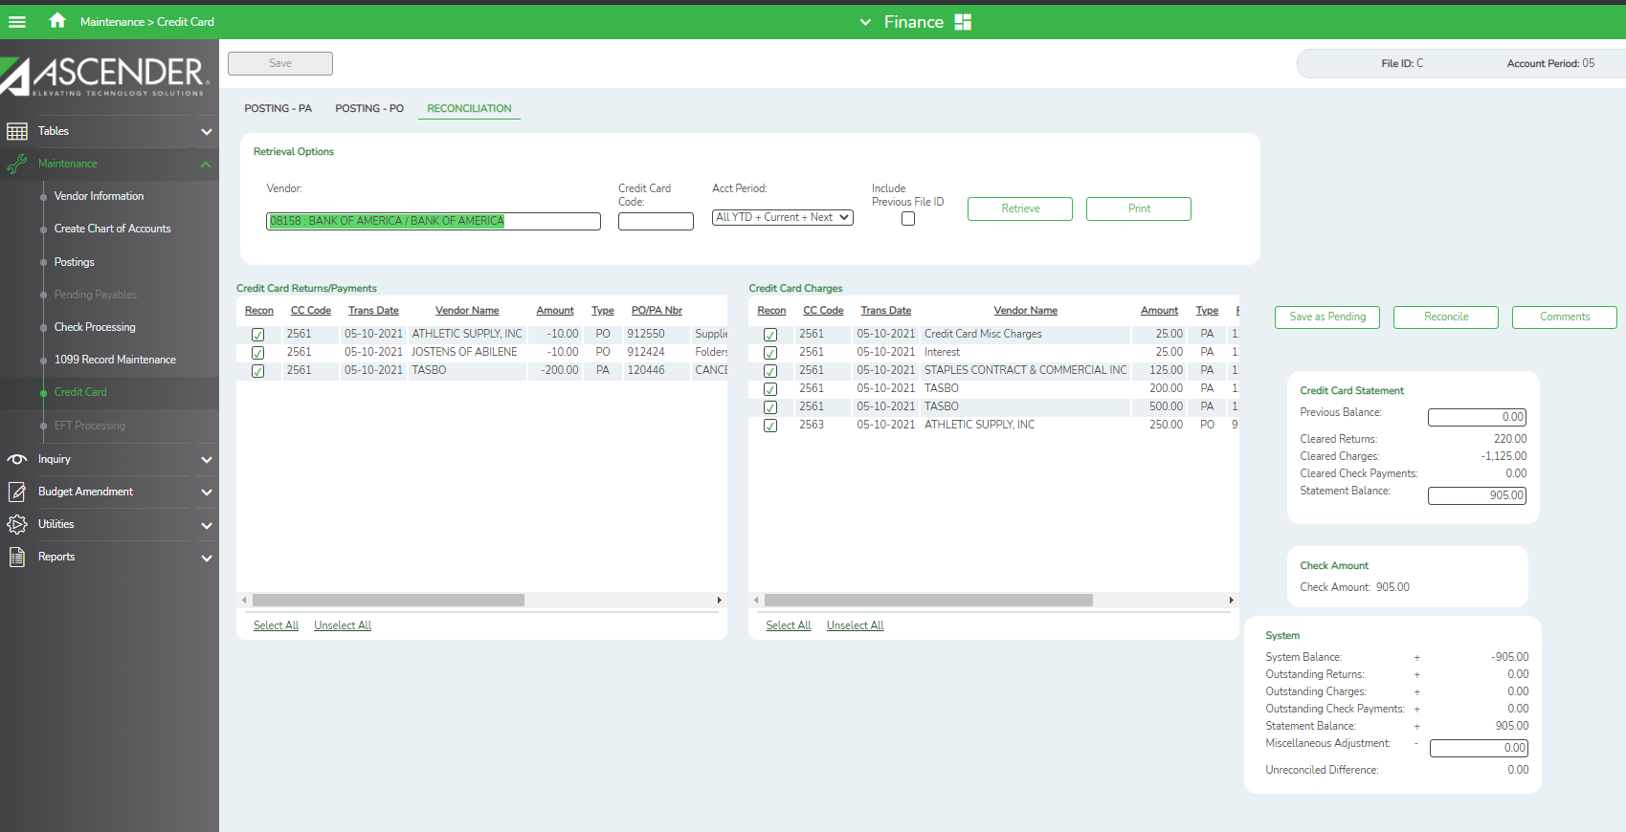

Example 2
Bank One Reconciliation

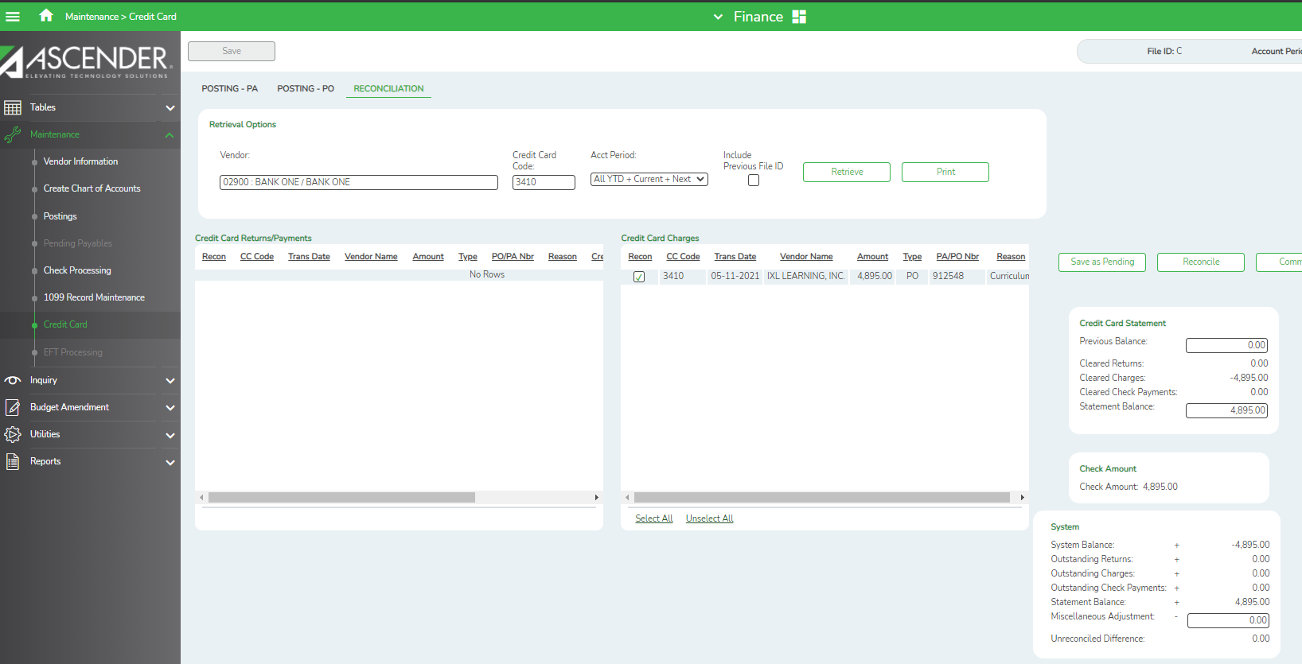

- Once the Reconcile button is selected, run the Reconciliation Reports

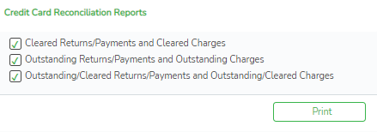

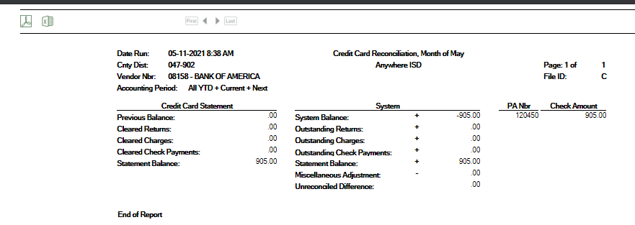

Ascender will create a PA or PO in the Check Processing to the credit card vendor.

- Enter the PA Number and click Retrieve or choose from the Directory.
Maintenance > Postings > Check Processing PA

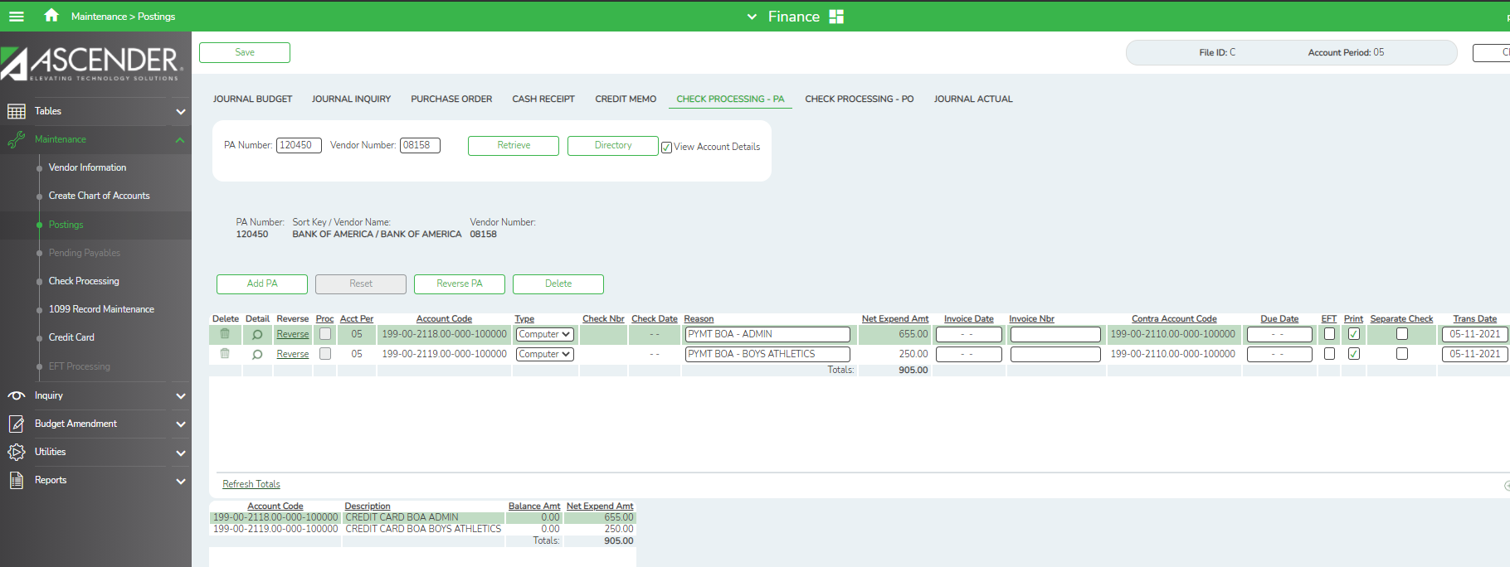

Maintenance > Postings > Check Processing PO

- Enter the Net Expend Amt and the Liquidated Amt.

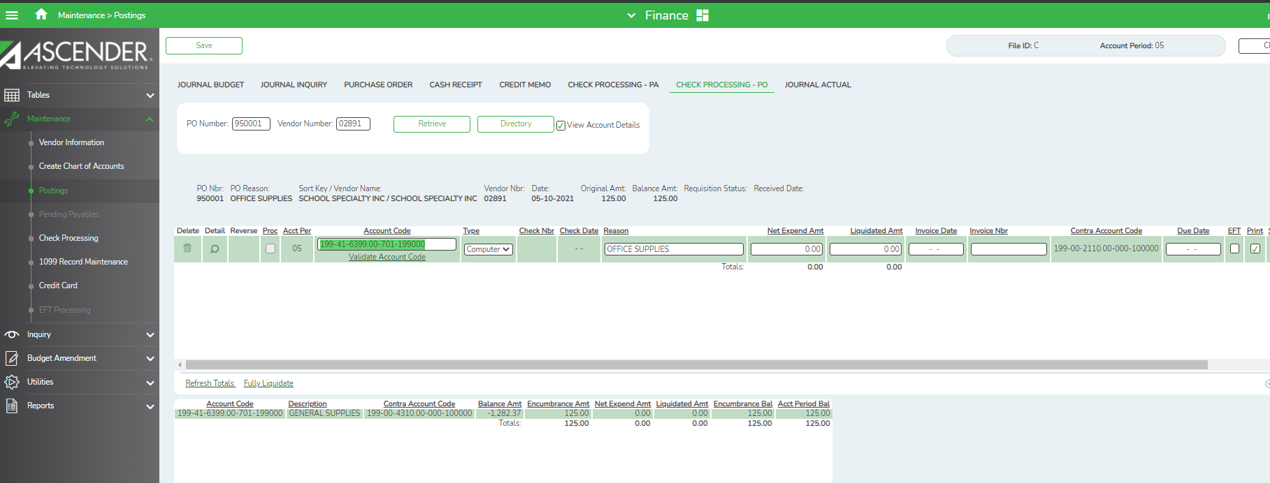

Check to Credit Card Company

A check will display to be printed to the credit card vendor.

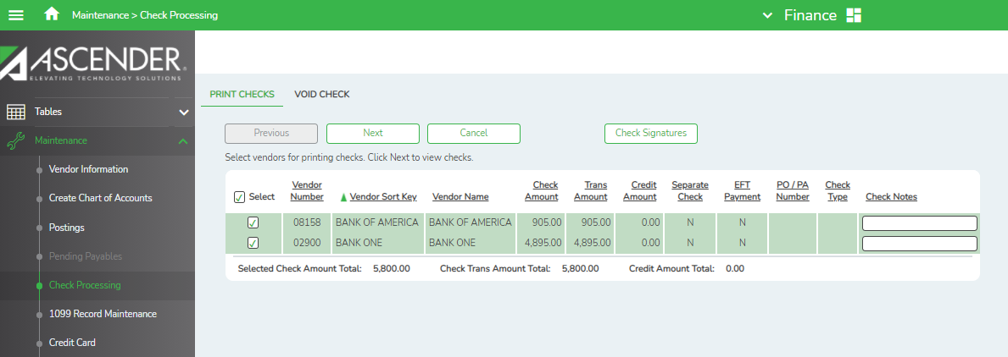

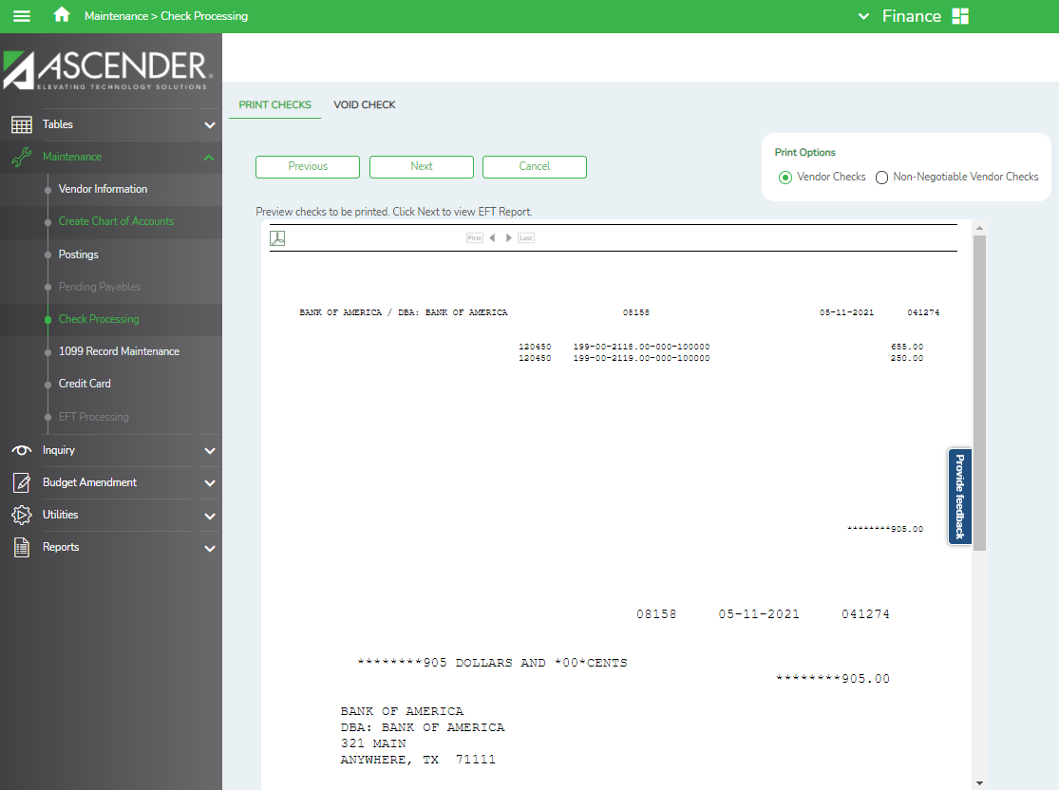

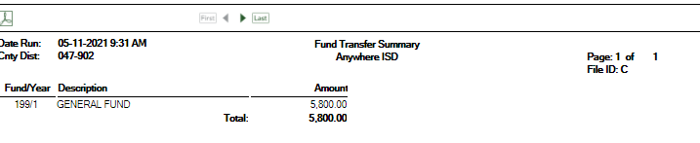
Total checks for
Bank of America is $905.
Bank One is $4895.
Credit Card Payment Listing

Reports > Finance Reports > Journals, Checks, Detail Ledgers >
FIN 1950 – Credit Card Payment Listing
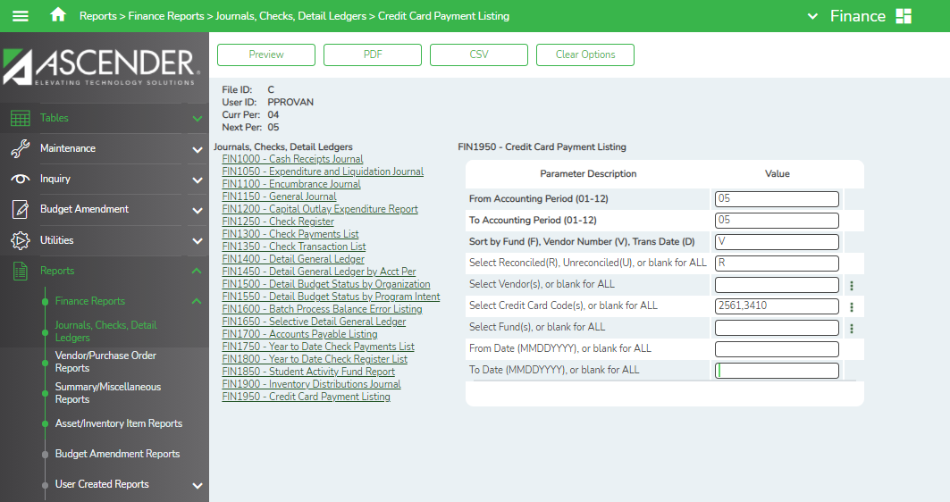
Examples of Values

Examples of Bank One- Credit Card Code 3410 - Payment listing

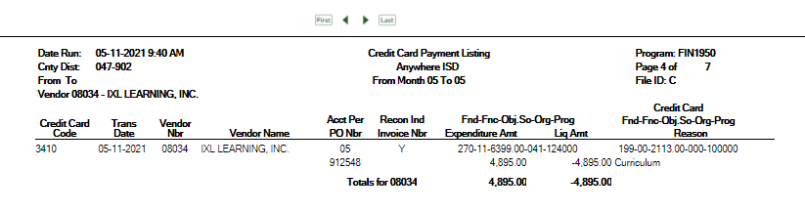

Examples of Bank of America – Admin – Credit Card Code 2561 & 2563 - Payment Listing

